Financial Markets

versus

Macro-Economic Indicators of USA

**Authors:**

**Rituraj Borah**

**Vidya Biradar**

**Sai Ganesh Darisa**

**Bhavitaben Upendrabhai Bhatt**

**Veera Santhosh Kumar Narapareddy**

**Summary**

In everyday conversations, people frequently discuss issues like inflation, unemployment, and economic downturns. However, there's often a noticeable absence of conversations regarding the fundamental drivers of the economy and financial markets. This gap can be attributed to poor financial literacy and the prevalence of emotionally driven or impulsive decision-making.

For our college capstone project, we aim to create a comprehensive and data-driven solution that delves deep into the crucial economic indicators that shape our financial landscape. This holistic initiative will centre on key metrics such as GDP, inflation (CPI), and unemployment rates, providing students and users with a robust foundation of knowledge to navigate the complex world of economics and finance.

Our objective is not merely to offer a surface-level understanding but to empower individuals with the tools and insights necessary to make informed and data-driven decisions. To achieve this, our project will also encompass an extensive array of financial market data, covering various facets of the financial ecosystem, including capital markets, debt markets, cryptocurrencies, and commodities markets.

By bringing together these diverse data sets and presenting them in an accessible and user-friendly format, we aim to bridge the knowledge gap that often hinders meaningful discussions and decision-making in these domains. We envision our project as a valuable resource for students, enthusiasts, and anyone seeking a deeper comprehension of the economic forces that shape our lives.

Ultimately, our goal is to create a more financially literate society where individuals can use data-driven insights to make sound financial decisions, advocate for their interests, and actively participate in shaping economic discourse. In doing so, we believe that we can contribute to a more informed and empowered citizenry, regardless of their level of engagement with the world of investment.

**Introduction**

Motivation

The motivation for this project arises from the interest in financial data and stock markets, the need to enhance financial data literacy and equip individuals, especially students of data analytics, with the knowledge and tools to make informed financial decisions. In today's world, economic factors and financial markets play a significant role in everyone's lives, yet many lack understanding of these topics.

This project is justified by its potential to bridge this knowledge gap by offering a data-driven solution that simplifies crucial economic indicators and financial market data. By empowering data and financial analytics students with the insights they need, we aim to create awareness about world financial data, promote financial data literacy and aid in data driven and informed decision-making.

Objectives

* Meet our course requirement in terms of a capstone project related to data analytics in a field.
* Promote financial data literacy and create awareness of macro-economic and financial markets data.
* Make students understand the major economic drivers and financial markets.
* Identify the relation between macro-economic indicators and financial markets of USA.
* Understand the major trends in financial markets of USA.
* Understanding time series data to build charts for analysis that results in an interactive dashboard.

**Methodology**

Data Sources

|  |  |  |  |
| --- | --- | --- | --- |
| **Name** | **Source** | **Collection method** | **Collection Date** |
| **Indices** | Yahoo Finance API | N/A  as we are downloading historic price information and not collecting any data. | NA |
| **Precious Metals (Gold and Silver)** |
| **Crude Oil** |
| **Cryptocurrency** |
| **Bonds** |
| **Maco-Economic Data** | Alphavantage API |

|  |  |  |  |
| --- | --- | --- | --- |
| **Name** | **Source** | **Collection Method** | **Date** |
| Financial Data awareness | Survey Data | Survey | 01/12/2023 |

The above list contains the asset classes that we are focusing on for our project. We have time series data for all the asset classes except for the news information that we are planning to include in our project later.

Data Collection methods and date are not applicable for this project as we are downloading readily available public sources of data, and our group is not involved in any collection of primary data *except for the financial data literacy survey*.

*Alpha Vantage* is a financial data platform providing real-time and historical data on stocks, commodities, currencies, and cryptocurrencies. It offers APIs for developers, technical indicators, charts, and analytics, making it useful for investors, traders, and developers. The platform offers both free and paid subscription options. We are using free API for the purpose of our project.

yfinance is a Python package that simplifies accessing a wide range of financial data from Yahoo Finance. It provides information like stock prices, historical data, financial statements, and more for various assets, including stocks, market indices, and cryptocurrencies. Widely used in finance and investment, it's a valuable tool for quantitative analysis, research, and portfolio management, helping users stay informed about market trends and asset performance.

Data for our project is currently being accessed on a python based interactive notebook using application programming interface (API) from Alphavantage and Yahoo Finance.

Data is time-series in nature and the timeline ranges anywhere from 1946 to December 2023 as of now, we plan to include more data points for the future period till our project is concluded (April 2024).

**Data Analysis**

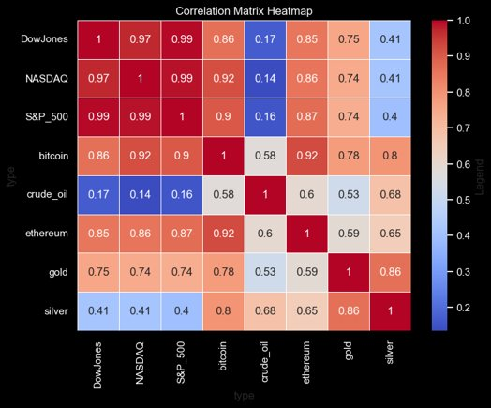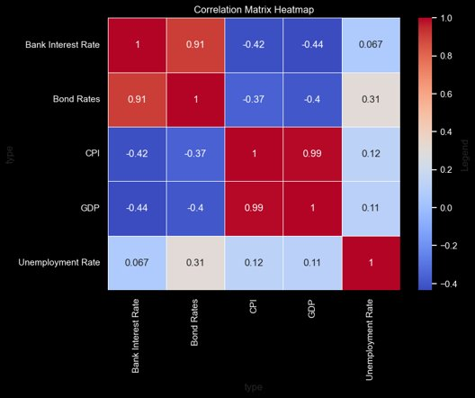

**Correlation Matrices of Financial Market data and Macro-Economic Indicators**

* The Dow Jones, NASDAQ, and S&P 500 are highly correlated, indicating similar market movement trends.
* Bitcoin and Ethereum are strongly correlated with each other and relatively moderate with stock indices, suggesting a partial integration with traditional markets.​
* Gold has a lower correlation with stocks than bitcoin, hinting at its potential as a diversification asset.
* Silver shows a high correlation with gold and varying lower correlations with other assets​.
* Bank Interest Rates and Bond Rates are strongly positively correlated, indicating they often move in tandem.​
* On the other hand, they are negatively correlated with Consumer Price Index (CPI) and Gross Domestic Product (GDP), suggesting that as rates increase, there may be downward pressure on prices and economic output.
* CPI and GDP are almost perfectly correlated, which may indicate that periods of economic growth are associated with increased inflation.​
* Unemployment Rate shows a very weak correlation with all other variables, implying it doesn't move strongly in sync with interest rates, inflation, or GDP.​
* The unemployment rate's weak correlations imply it's influenced by diverse factors beyond economic indicators, such as technology, globalization, policies, and education.

**Survey Data Analysis**

From the survey data analysis, we can understand that 66% of respondents are not from the field of finance, familiarity with financial market data and its terminology has been observed.

However, 66% of the respondents are not aware of the online sources to download financial data.

**Dashboard showing the macro-economic indicators**

**Dashboard showing the US Stock market Indices**

**Dashboard showing Commodities**

**Dashboard showing Crypto Currencies**

**Interpretations**

**Stock Market Correlations**: Dow Jones, NASDAQ, and S&P 500 are highly correlated, indicating similar market trends and integration.

**Cryptocurrency Integration**: Bitcoin and Ethereum move together and moderately with stocks, suggesting interplay between cryptocurrencies and traditional markets.

**Gold as a Diversification Asset**: Gold's lower correlation with stocks compared to Bitcoin hints at its potential as a diversification asset.

**Interest Rates and Economic Indicators:** Positive correlations between bank and bond rates suggest tandem movements, while negative correlations with CPI and GDP indicate potential disinflationary and growth impact as rates rise.

**CPI and GDP:** Strong positive correlation suggests economic growth often leads to increased inflation.

**Unemployment Rate**: Weak correlations imply it's influenced by diverse factors beyond economic indicators.

**Limitations**

**Causation vs. Correlation**: Correlation doesn't provide information about causation. Just because two variables are correlated doesn't mean one causes the other. There may be underlying factors driving both variables.

**External Factors and Shocks**: The analysis doesn't account for external factors such as geopolitical events, regulatory changes, or unexpected shocks that can significantly impact financial markets and economic indicators, potentially leading to deviations from expected correlations.

**Limited Variables**: The analysis focuses on a selected set of variables, which may not encompass all the relevant factors that can influence financial markets and economic indicators. Other unconsidered variables might play a significant role in the observed correlations.

**Lagged Effects**: Some economic indicators may have lagged effects on financial markets. Changes in economic variables may not immediately translate into market movements, and the timing and magnitude of these effects can vary.

**Market Sentiment**: Correlation analysis may not fully capture the influence of market sentiment, which can drive short-term market fluctuations independently of fundamental factors. Sentiment-driven movements can deviate from expected correlations.

**Recommendations**

**Correlation ≠ Causation**: Remember that a high correlation between variables doesn't imply causation. Be cautious when inferring causal relationships from correlations.

**Diversify Thoughtfully**: Consider diversifying your portfolio with assets like gold, which has lower correlations with stocks. This can help manage risk during market fluctuations.

**Lagged Effects Exist**: Economic indicators may have delayed impacts on financial markets. Don't rush investment decisions based solely on recent data; consider the timing and magnitude of effects.

**Future Work**

* Automation of data download​
* Hosting data on cloud database​
* Accessing cloud data on Tableau​
* Implementation of Machine Learning Models
* Implementation of Live Dashboards

**Appendix**



*Double Click on the above icon to access Python notebook.*

**CPI (Consumer Price Index)**: CPI is a measure of inflation that tracks changes in the prices of a basket of goods and services over time, providing insight into cost-of-living adjustments.

**GDP (Gross Domestic Product)**: GDP represents the total economic output of a country and is a key indicator of its economic health, encompassing all goods and services produced.

**Unemployment Rate**: The unemployment rate reveals the percentage of the labour force that is currently without a job, serving as an important gauge of economic stability.

**Bond Rates**: Bond rates refer to the interest rates at which governments and corporations borrow money by issuing bonds, influencing investment decisions and economic conditions.

**Bank Interest Rates**: These are the rates at which commercial banks lend money to consumers and businesses, impacting borrowing costs and savings returns.

**US Stock Market Indices**: US stock market indices, such as the S&P 500 and Dow Jones Industrial Average, track the performance of various stocks, reflecting overall market trends and investor sentiment.

**Bitcoin**: Bitcoin is a decentralized digital currency that operates on a blockchain, offering a store of value and a means of transferring assets outside traditional financial systems.

**Ethereum**: Ethereum is a blockchain platform that supports smart contracts and decentralized applications (DApps), expanding the use cases of blockchain technology beyond cryptocurrencies.

**Gold**: Gold is a precious metal often used as a store of value and a hedge against economic uncertainty due to its scarcity and historical significance.

**Silver**: Like gold, silver is a precious metal valued for its industrial and investment purposes, with applications in electronics and as a financial asset.

**References**

<https://www.alphavantage.co/documentation/>

<https://ca.finance.yahoo.com/>

<https://fred.stlouisfed.org/>

<https://www.spglobal.com/spdji/en/indices/equity/sp-500/#overview>

<https://help.tableau.com/current/pro/desktop/en-us/gettingstarted_overview.htm>

<https://matplotlib.org/>

<https://seaborn.pydata.org/>

[The Data School - How to build a candlestick chart in Tableau](https://www.thedataschool.co.uk/anna-prosvetova/how-to-build-a-candelstick-chart-in-tableau/)